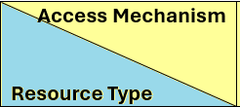 | Self-Production  Self-generated  Produce it ourselves | Aggregation  Combining from many individuals | Co-optation  Obtaining from other organizations | Patronage  Powerful and prestigious support
Human
- People
- Labor
- Skills
Material
- Money
- Space
- Equipment
Socio-organizational
- Networks
- Relationships
Cultural
- Narratives
- Knowledge
- Skills
Moral
- Legitimacy
- Trust
- Credibility

